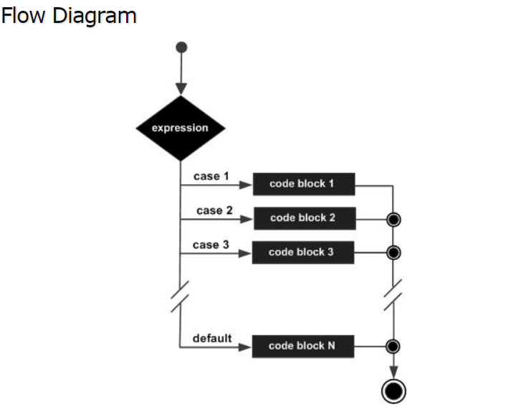
#include <stdio.h>

int main () {

/* local variable definition */
char grade = 'B';

switch(grade) {
case 'A' :
printf("Excellent!\n" );
break;
case 'B' :
case 'C' :
printf("Well done\n" );
break;
case 'D' :
printf("You passed\n" );
break;
case 'F' :
printf("Better try again\n" );
break;
default :
printf("Invalid grade\n" );
}

printf("Your grade is %c\n", grade );

return 0;
}

When the above code is compiled and executed, it produces the following result −
Well done
Your grade is B

